February 2021 Members Update
People With disabilities WA

Message from our Executive Director
People With disabilities WA (PWdWA) in collaboration with WA’s Individualised Services (WAiS) recently provided our submissions in response to the NDIS discussion papers on Access and Eligibility Policy with independent assessments and Planning Policy for Personalised Budgets and Plan Flexibility.
The submissions were informed by consultation with our members via a forum and online survey. Our submissions highlighted a number of concerns with both policies and provided numerous recommendations with the main recommendation to call for a halt to the implementation of both policies until further consultation and a co-design approach had been implemented. The full submissions are available at Our submissions | PWdWA PWdWA and WAIS thank their members for their invaluable contribution.

Diversity Field Officer Project
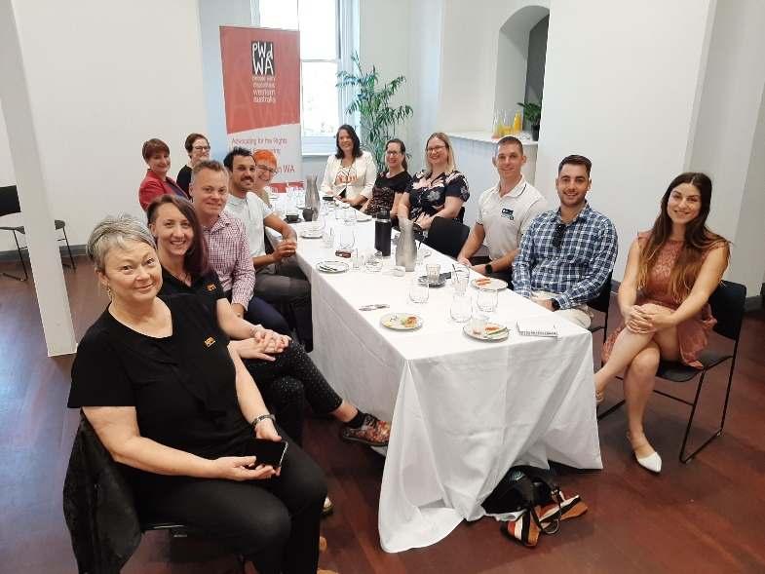
Photo: DFO business representatives and PWdWA staff including Chair, Lisa Burnette, at a thank-you breakfast at the State Building in Perth
The Diversity Field Officer project delivered by PWdWA and Advocacy WA supported tourism, hospitality and leisure businesses in the South West, Wheatbelt and Perth metropolitan communities to become champions of disability access and inclusion.
Targeted businesses were assisted in understanding the benefits of employing people with disability, and to have the tools to do so when they are able. The project concluded at the end of January with the initial evaluation showing that 71% of businesses involved rated the experience as ‘excellent’ with 92% noting that the recommendations provided from the DFO service as ‘helpful’ and ‘very helpful’. The results also indicated that the majority of business involved in the project were more confident in the safety and accessibility of their business, and in their ability to assist customers with disability. A final evaluation report will be on our webpage when completed.

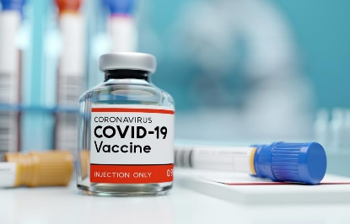

COVID-19 Vaccine Rollout
The Federal Government will commence rollout of the COVID-19 vaccine under Phase 1a in a small number of regions in WA from Tuesday 22 February.
People with disability, workers, and supporters eligible under Phase 1a of the rollout include:
- A person with disability living in residential accommodation (in settings with two or more people with disability only).
- A paid worker providing support to people living in residential accommodation with two more people with disability.
For Phase 1a, people with disability will be notified when it is their turn to receive a COVID-19 vaccination.
Information about the rollout is currently being developed into accessible formats such as Easy Read and Auslan and will be made available as soon as possible.
For further information, refer to the following COVID-19 Alert createsend.com/t/t-24EC5C9E212549412540EF23F30FEDED
You can also visit the Department of Health Information for people with disability about COVID-19 vaccines | Australian Government Department of Health

WA State Election 2021
We have placed information about accessing the WA State Election on our website. Technology Assisted Voting | PWdWA

There is also a list of Accessible Voting stations, on the Commission’s website WA Elections | Western Australian Electoral Commission. If you cannot access this please contact us for further information on 9420 7279 or 1800 193 331.

Leadership WA – LeadAbility Course

Inspire. Empower. Create. Contribute.
LeadAbility is a 6-day activity-based course aimed at empowering people with disability who wish to lead and generate change.
What will you learn?
- Project planning
- Communication Skill
- How to work in teams
- What good leadership looks like
On accepting a position to the LeadAbility Course, participants make a personal contribution of $250 (non-refundable) to confirm their position and commitment to the Course. Scholarship support for the personal fee is available and People With disabilities WA encourage you to apply for one. Tick the scholarship box on the application form and a Leadership WA Team member will contact you. Register your interest here LeadAbility Register | Leadership WA

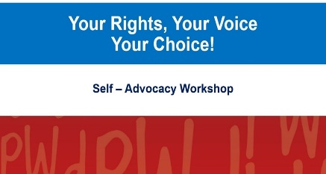

Your Rights, Your Voice, Your Choice

Self-Advocacy Workshops
PWdWA will be conducting three free two-part self-advocacy workshops over the coming months.
- Saturday, March 6 and Saturday, March 13 – Citiplace Community Centre, 12:00 pm – 5:00 pm.
- Saturday, April 10 and Saturday, April 17 – Online workshop presented through ZOOM, 10:00 am – 3:00 pm.
- Thursday, May 6 and Friday, May 7 – Citiplace Community Centre, 12:00 pm – 5:00 pm.

Registration can be made through Eventbrite PWdWA Events Events | Eventbrite or by calling Vanessa on 08 9420 7279.

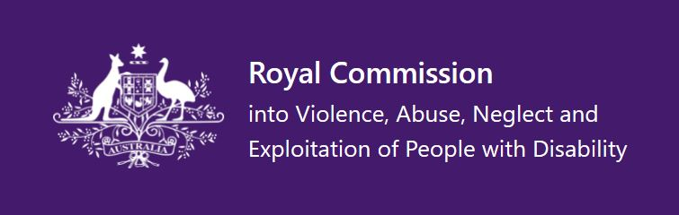

Royal Commission into Violence, Abuses, Neglect and Exploitation of People with Disability

Promoting Inclusion

Submission close by April 2
This issues paper is asking the public to share their views on what an inclusive society looks like. The paper asks nine questions and is available in Easy Read, PDF and DOCX. Promoting inclusion | Royal Commission into Violence, Abuse, Neglect and Exploitation of People with Disability.

Third Progress Report
The Royal Commission has released its third progress report summarising the work carried out by the commission between July 1, 2020 and December 30, 2020. The report is available in Easy Read, PDF, DOCX and Auslan. Third Progress Report | Royal Commission into Violence, Abuse, Neglect and Exploitation of People with Disability.

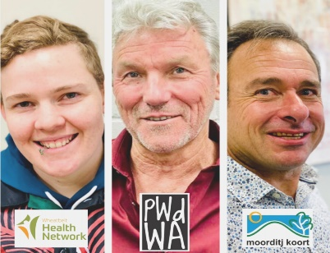

Wheatbelt Disability Information Roadshow
People with disabilities, Aboriginal people, their families and carers in the Wheatbelt are invited to attend the Wheatbelt Disability Roadshow. Mark, our Individual Advocate Regional Outreach officer will be joining Wheatbelt Health Network and Moorditj Koort at the following towns:
- Jurien Bay, Tuesday 2 March – Jurien Bay Civic Centre
- Moora, Thursday 4 March – Amity Health, Moora Arcade
- Kellerberrin, Monday 8 March – Centenary Park, Kellerberrin
- Merredin, Tuesday 9 March – Merredin Tourist Information Centre
The purpose of these events is to provide information, advocacy, and support to assist people with disability with problems or issues they are having trouble resolving.
We can provide information on:
- any issues individuals are having with school, community, housing, agencies, neighbours, police, or the law
- disability supports individuals might like to access
- information about NDIS - access, supports, services
- whether individuals are eligible for a Disability Support Pension or Carers Allowance
Please share this information with anyone you think may be interested and contact mark@pwdwa.org or call 9420 7279 for more information.

PWdWA
PWdWA is run BY and FOR people with disabilities and aims to be the voice for all people with disabilities in Western Australia.

Free membership
If you know someone with a disability who would like to join our organisation, our membership is free for people with disability to become full members https://www.pwdwa.org/get_involved/become_a_member.html

Keep up to date with our regular posts to Facebook and Twitter
https://www.facebook.com/PeopleWithdisabilityWA/?ref=aymt_homepage_panel

