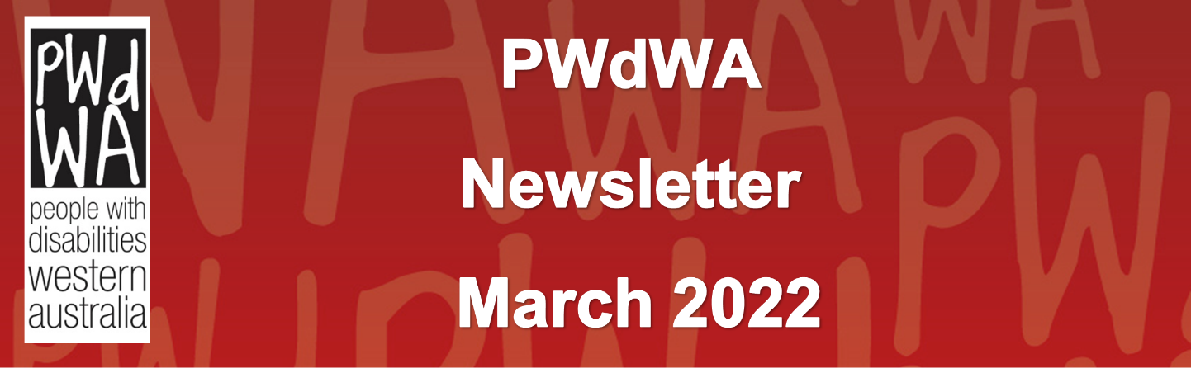
- Message from PWdWA
- Current Issues
- PWdWA Profile
- PWdWA in Action
- Upcoming

Message from PWdWA
Four Corners Guardianship and Administration Investigation sheds light on abusive systems
The ABC Four Corners Program ‘State Control’ which aired on 14 March 2022 sheds light on the systemic abuse experienced by people with disabilities subjected to Guardianship and Administration systems across Australia. PWdWA stands with and for those who have experienced this abuse and exploitation, and those who are speaking out.
While shocking, these allegations are unfortunately not surprising. PWdWA has long advocated for the end of substitute decision-making systems which not only violate human rights, but also expose people to abuse and harm. We are working to make a submission about this very issue to the Royal Commission into Violence, Abuse, Neglect and Exploitation of People with Disability.
PWdWA have seen firsthand the trauma these systems cause, and the impact of having decision-making rights stripped away. Enough is enough. Australia must commit to reform and meet its obligations under the Convention on the Rights of Persons with Disabilities (CRPD).
In light of the Four Corners report and the growing voice of people with disabilities who have lost their fundamental rights to self-determine, PWdWA calls on the Western Australian government to commit to abolishing substitute decision-making and ensure supported decision-making and autonomy for people with disabilities are enshrined in our laws.
We also call on the Royal Commission into Violence, Abuse, Neglect and Exploitation of People with Disability to schedule a hearing examining substitute decision-making systems for people with disability as a matter of priority.
If you or someone you know has experienced abuse in the Guardianship or Administration system, support is available. You can tell the Royal Commission your story by making a submission or requesting a private session. You can also contact PWdWA on 9470 7279 for advice and support.

Current Issues

Down to 10 Days Petition
Right now, there are more than 1100 Australians with disability who are waiting in hospital beds, in nursing homes and with their families who are unable to care for them. They are waiting to live in a home that meet their needs. Waiting for the NDIS support they are entitled to.
PWdWA has joined The Summer Foundation and an alliance of people with disability, other advocacy organisations and the housing, health, and disability sectors to call for the National Disability Insurance Agency (NDIA) to provide approval for housing and support to people with disability within 10 days.
Sign the petition on their website. There is an opportunity to have the Summer Foundation contact you to share your story.

No Excuse for Abuse
People With disabilities WA express our concerns for appalling and offensive comments made during the recent trial of a disability support worker who pleaded guilty to the manslaughter of Adelaide woman, Anne-Marie Smith. Ms Smith died as a result of shocking neglect in 2020.
To insinuate that someone being alleged ‘a stubborn and difficult person’ is somehow an excuse for neglect is an appalling and distasteful comment that reeks of victim-blaming. The ‘wheels’ for her care should have never fallen off as Ann-Marie was a vulnerable person entitled to receive care in a safe environment. It is the duty of the professionals who were being entrusted and paid to provide this support. No excuse can justify pure neglect or abrogation of responsibility.
People with disabilities have the rights to be treated with dignity and be empowered to make decisions and speak out. The voices of the vulnerable should not be ignored or belittled to insignificance as it is not convenient for the professionals to make appropriate changes.
The tragic death of Ann-Marie is laced with people turning a blind eye to a vulnerable person and it got to a stage where it led to her tragic death.
PWdWA stands with and for people of all disabilities to ensure that the voices and rights of people like Ms Smith do not go unheard.
While changes have been implemented following this very tragic incident, the disability community needs to remain vigilant to ensure this situation never occurs again.

PWdWA Profile

Nihal Iscel – Vice Chair of the board
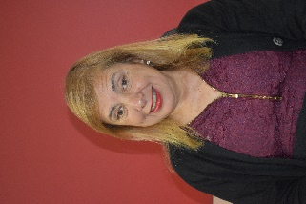
PWdWA would like to congratulate our Board member Nihal Iscel on being inducted into the WA Women’s Hall of Fame for her advocacy work with people with disability from culturally and linguistically diverse backgrounds.
Nihal has been working in the multicultural and disability sectors for almost 20 years in various roles supporting people from refugee, humanitarian entrant and migrant backgrounds including people with disability. She currently works at the Ethnic Communities Council of WA Inc as the Speak My Language (disability) WA Coordinator

Note: Richard (Dick) Fletcher Award
In our February newsletter we mentioned the winner of the Richard (Dick) Fletcher Award in the 2022 Consumer Protection Awards would be announced on 18 March 2022. Due to the uptake in COVID-19 numbers the announcements have been postponed until later in the year. We will keep you posted.

PWdWA in Action

Systemic Advocacy Survey
Did you know that when you complete a PWdWA survey it directly informs our submissions and systemic advocacy?

Systemic advocacy is an important part of PWdWA’s work. It is important for us to understand what areas of systemic advocacy you think we need to focus on.

PWdWA invites our members to have their say on our systemic advocacy work. This survey will help inform our priority areas for systemic advocacy and ensure your voice is heard when we are advocating for people with disabilities in WA.

If you need help with the survey, please contact Vanessa on 9420 7279. We can also arrange for the questions to be provided via email, SMS, Facebook messenger or other alternative forms of communication.
You can find the survey online at https://www.surveymonkey.com/r/LBJHZ9W

Our Annual Member Survey
Thank you to all our members who responded to our survey; your feedback has been presented to the board.
Congratulations to Marianne and Craig, the winners of our $100.00 gift vouchers. All our full and associate members who responded to the survey will be entered into our International Day for People with Disability lunch competition on 3 December 2022.

Upcoming

PWdWA’s Disability Support Pension Online Information Session

Friday 1 April 2022 10:00 am – 12:00 pm
This session will be especially useful to people who are about to apply for the Disability Support Pension (DSP). It will help you prepare and submit a strong application for DSP by understanding:
- If you are eligible to apply.
- The Centrelink DSP process.
- What information Centrelink needs to assess in your application.
- What is good medical evidence and how to get it from your health professionals.
- Things you need to know about the program of Support, Job Capacity Assessment and Disability Medical Assessment.
At the end of the session, you will have a good idea of how Centrelink will assess your application. We will also provide with tools and links to additional resources that can help you.
You can register for this event through https://bit.ly/36E75Cw or call Vanessa on 9420 7279 ext. 717 or email vanessa@pwdwa.org.

PWdWA
PWdWA is run BY and FOR people with disabilities and aims to be the voice for all people with disabilities in Western Australia.
Free membership
Being a member of People With disabilities WA (PWdWA) gives you the opportunity to be involved in shaping our organisation through our planning and evaluation processes. As a member, you can make sure the issues that matter to you are heard, by being involved with our submissions and advocacy campaigns. Voting is restricted to full members aged 15 years and above.
Full Membership is available to persons living in Western Australia, with a disability, over the age of 15 years who are Australian citizens or permanent residents of Australia.

